Batch: B2 Roll No.: 16010121200

Experiment No. 07

Grade: AA / AB / BB / BC / CC / CD /DD

Signature of the Staff In-charge with date

TITLE: Simulate Bankers Algorithm for Deadlock Avoidance
_____________________________________________________________________

AIM: Implementation of Banker’s Algorithm for Deadlock Avoidance
______________________________________________________________________
Expected Outcome of Experiment:

CO 3. To understand the concepts of process synchronization and deadlock.
______________________________________________________________________
Books/ Journals/ Websites referred:

- Silberschatz A., Galvin P., Gagne G. “Operating Systems Principles”, Willey Eight edition.
- Achyut S. Godbole , Atul Kahate “Operating Systems” McGraw Hill Third
Edition.
- William Stallings, “Operating System Internal & Design Principles”, Pearson.
- Andrew S. Tanenbaum, “Modern Operating System”, Prentice Hall.
_____________________________________________________________________
Pre Lab/ Prior Concepts:

Knowledge of deadlock and all deadlock avoidance methods

Description of the application to be implemented:
The Banker's algorithm is a resource allocation and deadlock avoidance algorithm developed by Edsger Dijkstra.

DATA STRUCTURES
(where n is the number of processes in the system and m is the number of resource types)

Available
- It is a 1-d array of size ‘m’ indicating the number of available resources of each type.
- Available[j] = k means there are ‘k’ instances of resource type R_{j}

Maximum
- It is a 2-d array of size ‘n*m’ that defines the maximum demand of each process in a system.
- Maximum[i, j] = k means process P_{i} may request at most ‘k’ instances of resource type R_{j}

Allocated
- It is a 2-d array of size ‘n*m’ that defines the number of resources of each type currently allocated to each process.
- Allocated[i, j] = k means process P_{i} is currently allocated ‘k’ instances of resource type R_{j}

Need
- It is a 2-d array of size ‘n*m’ that indicates the remaining resource need of each process.
- Need[i,j] = k means process P_{i} currently needs ‘k’ instances of resource type R_{j}
- Need[i,j] = Maximum[i,j] – Allocated[i,j]

Allocated specifies the resources currently allocated to process P_{i} and Need_{i} specifies the additional resources that process P_{i} may still request to complete its task.

Implementation details: (printout of code)
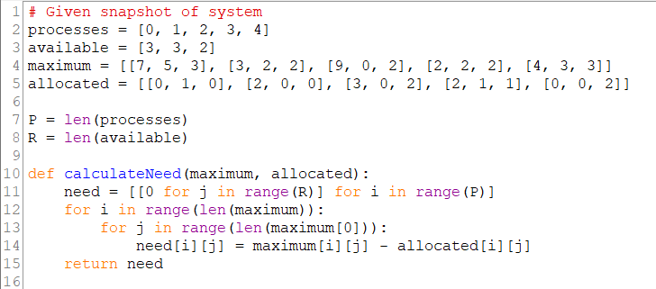
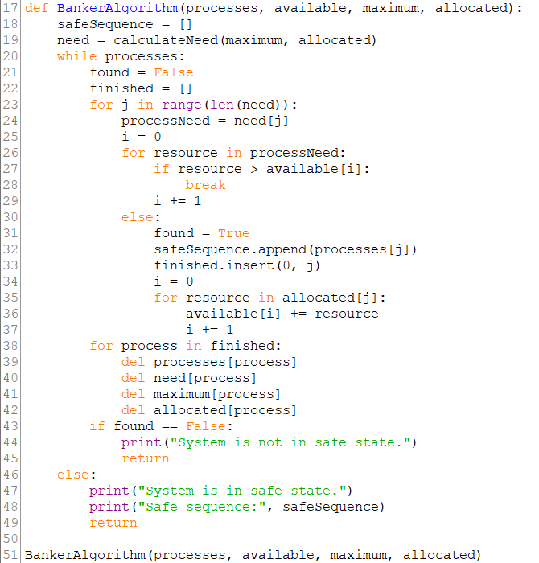

Output:
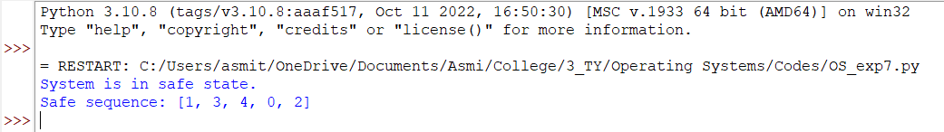
Conclusion:
Understood concepts of process synchronization and deadlocks.
Successfully implemented Banker’s Algorithm for deadlock avoidance.
Post Lab Objective Questions

- The wait-for graph is a deadlock detection algorithm that is applicable when:
  - All resources have a single instance
  - All resources have multiple instances
  - Both a and b
  - None of the above

- Resources are allocated to the process on non-sharable basis is
  - Hold and Wait
  - Mutual Exclusion
  - No pre-emption
  - Circular Wait

- Which of the following approaches require knowledge of the system state?
  - Deadlock Detection
  - Deadlock Prevention
  - Deadlock Avoidance
  - All of the above

- Consider a system having ‘m’ resources of the same type. These resources are shared by 3 processes A, B, C which have peak time demands of 3, 4, 6 respectively. The minimum value of ‘m’ that ensures that deadlock will never occur is
  - 11
  - 12
  - 13
  - 14
Post Lab Descriptive Questions
1. Consider a system with total of 150 units of memory allocated to three processes as shown:
Process | Max | Hold
P₁ | 70 | 45
P₂ | 60 | 40
P₃ | 60 | 15
Apply Banker’s algorithm to determine whether it would be safe to grant each of the following request. If yes, indicate sequence of termination that could be possible.
- The P4 process arrives with max need of 60 and initial need of 25 units.
Process | Max | Hold | Need
P₁ | 70 | 45 | 25
P₂ | 60 | 40 | 20
P₃ | 60 | 15 | 45
P₄ | 60 | 35 | 25

Available units = 150 – 45 – 40 – 15 – 35 = 15 units
None of the process requirements can be met.
Thus, deadlock occurs.
- The P4 process arrives with max need of 60 and initial need of 35 units.
Process | Max | Hold | Need
P₁ | 70 | 45 | 25
P₂ | 60 | 40 | 20
P₃ | 60 | 15 | 45
P₄ | 60 | 25 | 35

Available units = 150 – 45 – 40 – 15 – 25 = 25 units.
Allocate 25 units to process P₁. 0 units remaining.
Process P₁ will be completed.
70 units released; 70 units available.
Allocate 20 units to process P₂. 50 units remaining.
Process P₂ will be completed.
60 units released; 110 units available.
Allocate 45 units to process P₃. 65 units remaining.
Process P₃ will be completed.
60 units released; 125 units available.
Allocate 35 units to process P₄. 90 units remaining.
Process P₄ will be completed.
60 units released; 150 units available.

Date: 3/10/2023 Signature of faculty in-charge

